BSCS - 2018
Muhammad Ahmad sajjad

EDUCATION & QUALIFICATION
University of Sargodha 2018-2022
BSCS(Honors)

Superior college sargodha
2014-2016
F.SC in pre-engineering
Subjects: Mathematics, Chemistry, physics

Sanai school system 2014
Matric In science

PROJECTS

IOT based smart car parking system

ACTIVITIES, HONORS, & AWARDS
Event Management Society- University of Sargodha 2017-2022

SKILLS & TOOLS
Tools: Blender 3d, Android studio, Visual Studio, Android Studio
SQL Server Management Studio.
Microsoft Office, Coral, illustrator, Photoshop, Audacity,
Microsoft Visual, Eclipse, , SPS,MS Visio Pro ,Font Lab.

Skills: Android Development (certified), .Net Development (Certified), Web
Development (HTML 5), Java Development.
Languages: C#, C, C++, JAVA, HTML, bootstrap, JavaScript,

INTERESTS
Reading, playing pc games, volunteering in university events, farming and construction.

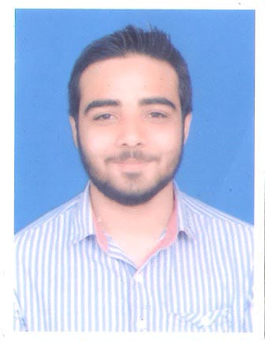

Date of Birth 22/07/1999
Business Address CS & IT Department
University of Sargodha University Road, Sargodha, Pakistan
Cell: 03087097733
Email: ahmadsajjad7733@gmail.com

